# INTRODUCTION TO PROJECT

The web based “Airline Reservation System” project is an attempt to stimulate the basic concepts of airline reservation system. The system enables the customer to do the things such as search for airline flights for two travel cities on a specified date, choose a flight based on the details and reservation of flight

The system provides you Quick Search facility that provides you details about flights without login . But if user want to book ticket then it must require login into your account.

The system allows the airline passenger to search for flights that are available between the two travel cities, namely the “Departure city” and “Destination city” for a particular departure and arrival dates. The system displays all the flight’s details such as flight no, name, price and time of journey etc.

Here we provided quick search facility which displays list of available flights and allows customer to choose a particular flight. Then the system checks for the availability of seats on the flight. If the seats are available then the system allows the passenger to book a seat. Otherwise it asks the user to choose another flight.

To book a flight the system asks the customer to enter his details such as name, address, city, state, credit card number and contact number. Then it checks the validity of card and book the flight and update the airline database and user database.

**2.REQUIREMENTS**

**2.1 FUNCTIONAL REQUIREMENTS**

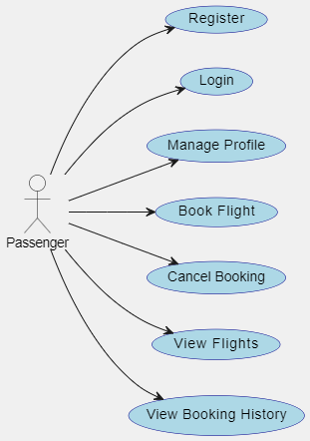

**2.1 User Account**

The Flight Reservation System using Spring Boot & React JS contains 2 modules i.e. Administrator & Customer whereCustomers can Book Flights by selecting the Flight Seat class type from Economy, Business, or First Class. So here if Flight Seat will be available then the customer ticket will immediately get confirmed. And if Seats are not available then his ticket booking will go to the waiting queue. Later if any customer cancels his confirmed ticket then the customer ticket that was in the waiting queue will get confirmed immediately.

After this customer can view all the Flight ticket booking history and the admin can see all the customer's flight ticket bookings in the dashboard. Once the Flight gets completed Admin can update the Flight status as Completed and now this will not be visible on the Website.

**2.2 Registration and creation of user profile**

The system shall require a user to register, in order to carry out any transactions with it except for checking the availability of tickets. It will ask the user for the following information at the least – a user id, a password, first name, last name, address, phone number, email, address, sex, age. The system will automatically create a ‘wallet’ field and initialize it to zero in the user’s profile. 

* 1. **Quick Search**

Here we provided Quick Search facility for any user to search flight schedule without login into account .This will provide user an option for searching flight and comparing their prices of all companies.

After logging in a user, the system shall request him to enter the following details – origin city and destination city. “City’ is a generic term and refers to a city or town as the case may be. The original destination cities would be entered as text.

After the origin and destination cities are ascertained, the system shall now access the flight schedule database, referred to as ‘flight’, and checks if there is a direct operational service between the two cities.

The system shall now ask the user to enter the following details - class, one-way, departure date and the number of passengers. ‘Class’ refers to Business class/Economy class/First. This choice shall be made by the user through a drop down menu indicating all the possible combinations of choices.

Having taken all the above input from the user, the system checks for any false entries like the departure date, arrival date. In case of incompatibility, the system will not display any flights available.

The system queries the flights database ‘flight’ to check which of the flights on the schedule have seats available. The system displays the results in a suitable form (a tabular form) with the following information depicted – for each airlineId , flight number, departure time in origin city, arrival time in destination city, departure city, arrival city ,Ticket price and the number of seats available on that flight.

There can be several flights of different airlines between two cities and all of them will be listed for the particular date that the user wants to depart from the Origin City. There will be a Book button in front of every row displayed n the table of flights searched.

The system will then ask for personal information of all passengers i.e. one registered user can book for multiple users. So all users will be added in the table.

The system shall now display the price of the ticket for the trip. This will be the sum of the prices for all the members of the travel party being represented by the user.

* 1. **Making Reservations/Blocking/Confirmation**

After having taken the user through the step 2.2, Checking Availability, The system will now ask the user if he wishes to block/buy the ticket. If yes, and

1. if the user has been a guest, he will have to first register and become a registered user and then log onto the system.
2. If the user is already a registered user, and if he has logged on already, he can block/buy the ticket, but if he has been acting as a guest, he will have to log on.

Having taken the input from the user in 3.4.2, the system shall now proceed to update the reservation database DB-reservation. It will decrement the number of available seats on the particular flight for the particular class by the number of travelers being represented by the user.

In case the user buys the ticket, the system decrease the wallet balance by

ticket price.

**2.5 View Booking History**

The system shall allow a user to view all information about his previous bookings. After logging him on, it asks for his blocking number or his confirmation number. It accesses UserBookingtable and retrieves the details of the trip and presents them to the user in a tabular format.

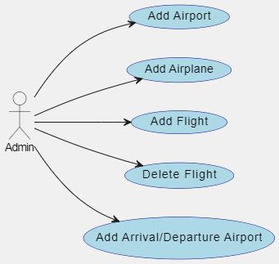

Admin can add the Airports in the systems, after adding Airports, he can add the Airplanes. Now Admin can add the Flights in the system by selecting the Departure and Arrival Airports with the Departure and Arrival time and at this time Admin has to set the fare for Economy, Business, and First Class seats. Once a Flight gets added to the system it will be visible to all the customers and also they can search for the Flights by selecting the Departure and Arrival Airport with the time range.

* 1. **NON FUNCTIONAL REQUIREMENTS**

**2.2.1 Interface**

Go to Appendix B for user interfaces

**2.2.2 Performance**

• **Startup Time**: The Spring Boot server starts within approximately 10 seconds on this hardware. Initial loading of dependencies slightly impacts startup time, but overall, the application is responsive.

• **Response Time**: API response times were measured using Postman. For basic CRUD operations, the average response time was around 150ms. More complex operations, such as querying flights with multiple filters, had an average response time of 300ms.

**2.2.3 Resource Utilization**

* **CPU and Memory Usage**: During typical usage, the application consumed about 40% CPU and 1.5GB of RAM. Under simulated load, CPU usage spiked to 70%, and RAM usage increased to 2.5GB. The application remained stable, with no crashes or memory leaks observed.
* **Disk I/O**: Disk usage was minimal, with most operations being read-heavy. The SSD helped in maintaining quick read/write operations, contributing to the overall responsiveness of the system.

**3. DESIGN**

**3.1 Database Design**

The following table structures depict the database design.

# Table1: User

|  |  |  |  |  |
| --- | --- | --- | --- | --- |
| **Key Type/ Constraint** | **Column Name** | **Data Type** | **Length** | **Allow Null (1=Yes;0=No)** |
| 1 | id | int | 4 | 0 |
| 0 | city | varchar | 255 | 1 |
| 0 | contact | varchar | 255 | 1 |
| 0 | email | varchar | 255 | 1 |
| 0 | gender | varchar | 255 | 1 |
| 0 | name | varchar | 255 | 1 |
| 0 | password | varchar | 255 | 1 |
| 0 | roles | varchar | 255 | 1 |
| 0 | status | varchar | 255 | 1 |
| 0 | street | varchar | 255 | 1 |
| 0 | Wallet_amount | decimal | 38,2 | 1 |

## **Table2: Airport**

|  |  |  |  |  |
| --- | --- | --- | --- | --- |
| 1 | id | int | 4 | 0 |
| 0 | address | varchar | 255 | 1 |
| 0 | code | varchar | 255 | 1 |
| 0 | location | varchar | 255 | 1 |
| 0 | name | varchar | 255 | 1 |

## **Table3: Airplane**

|  |  |  |  |  |
| --- | --- | --- | --- | --- |
| 1 | id | int | 4 | 0 |
| 0 | business_seats | int | 4 | 1 |
| 0 | description | varchar | 255 | 1 |
| 0 | economy_seats | int | 4 | 1 |
| 0 | name | varchar | 255 | 1 |
| 0 | registration_number | varchar | 255 | 1 |
| 0 | status | varchar | 255 | 1 |
| 0 | total_seat | int | 4 | 1 |
| 0 | first_class_seats | int | 4 | 1 |

**Table4: Airplane_Seat_no**

|  |  |  |  |  |
| --- | --- | --- | --- | --- |
| 1 | id | varchar | 255 | 1 |
| 0 | seat_ | int | 4 | 1 |
| 1 | airplane_id | int | 4 | 1 |

## **Table5: Flight**

|  |  |  |  |  |
| --- | --- | --- | --- | --- |
| 1 | id | int | 4 | 0 |
| 0 | arrival_time | varchar | 255 | 1 |
| 0 | business_seat_fare | decimal | 38,2 | 1 |
| 0 | business_seats | int | 4 | 1 |
| 0 | departure_time | varchar | 255 | 1 |
| 0 | economy_seat_fare | decimal | 38,2 | 1 |
| 0 | economy_seats | int | 4 | 1 |
| 0 | first_class_seat_fare | decimal | 38,2 | 1 |
| 0 | first_class_seats | int | 4 | 1 |
| 0 | flight_number | varchar | 255 | 1 |
| 0 | status | varchar | 255 | 1 |
| 0 | total_seat | int | 4 | 1 |
| 1 | airplane_id | int | 4 | 0 |
| 1 | arrival_airport_id | int | 4 | 0 |
| 1 | departure_airport_id | int | 4 | 0 |

## **Table5: Flight_booking**

|  |  |  |  |  |
| --- | --- | --- | --- | --- |
| 1 | id | int | 4 | 0 |
| 0 | booking_id | varchar | 255 | 1 |
| 0 | booking_time | varchar | 255 | 1 |
| 0 | flight_class | varchar | 255 | 1 |
| 1 | airplane_seat_no | int | 4 | 1 |
| 1 | flight_id | int | 4 | 1 |
| 1 | passenger_id | int | 4 | 1 |

**E-R Diagram,Dataflow diagram and Class Diagram:**

Go to Appendix A

**4. CODING STANDARDS IMPLEMENTED**

### Naming and Capitalization

Below summarizes the naming recommendations for identifiers in Pascal casing is used mainly (i.e. capitalize first letter of each word) with camel casing (capitalize each word except for the first one) being used in certain circumstances.

|  |  |  |  |
| --- | --- | --- | --- |
| **Identifier** | **Case** | **Examples** | **Additional Notes** |
| Class | Pascal | Person, BankVault, SMSMessage, Dept | Class names should be based on "objects" or "real things" and should generally be **nouns**. No ‘_’ signs allowed. Do not use type prefixes like ‘C’ for class. |
| Method | Camel | getDetails, updateStore | Methods should use **verbs** or verb phrases. |
| Parameter | Camel | personName, bankCode | Use descriptive parameter names. Parameter names should be descriptive enough that the name of the parameter and its type can be used to determine its meaning in most scenarios. |
| Interface | Pascal with "I" prefix | Disposable | Do not use the ‘_’ sign |
| Property | Pascal | ForeColor, BackColor | Use a noun or noun phrase to name properties. |
| Associated private member variable | _camelCase | _foreColor, _backColor | Use underscore camel casing for the private member variables |
| Exception Class | Pascal with "Exception" suffix | WebException, |  |

### Comments

* Comment each type, each non-public type member, and each region declaration.
* Use end-line comments only on variable declaration lines. End-line comments are comments that follow code on a single line.
* Separate comments from comment delimiters (apostrophe) or // with one space.
* Begin the comment text with an uppercase letter.
* End the comment with a period.
* Explain the code; do not repeat it.

**5. TEST REPORT**

**Another group called Linux did the testing and the report of the testing is given hereunder.**

**GENERAL TESTING:**

|  |  |  |  |  |
| --- | --- | --- | --- | --- |
| **SR-NO** | **TEST CASE** | **EXPECTED RESULT** | **ACTUAL RESULT** | **ERROR MESSAGE** |
| 1 | Register Page | Redirected to Next page | OK | Nothing |
| 2 | Login Page | Pop-up will come | Ok | Please enter username and password again . |
| 3 | Quick search flight | Gives all flight details | Ok | Nothing |
| 4 | Booking Ticket | All the fields should be filled for submission | Ok | Nothing |
| 5 | Checking login or not | User is logged in or not | Ok | Nothing |
| 6 | Add person details for tickets | Add informations according to no of seats allocated | Ok | Nothing |
| 7 | Goto ticket page | Set added information about person | Ok | Nothing |
| 8 | Add information in booking table | Save this all data into booking table | Ok | Nothing |
| 9 | Transaction | On back it should be reverted to previous page | Ok | Nothing |
| 11 | View transaction done | It shows you all transactions done previously | Ok | Nothing |
| 12 | Logout | It will logout from user profile. | Ok | Nothing |

**6. PROJECT MANAGEMENT RELATED STATISTICS**

|  |  |  |  |
| --- | --- | --- | --- |
| **DATE** | **WORK PERFORMED** | ****SLC Phase**** | **Additional Notes** |
| July 25,2024 | Project Allotment and User Requirements Gathering | Feasibility Study | Our team met the client Mr. Nitinkudale (CEO, SIIT Pune) to know his requirements. |
| Aug 1,2024 | Initial SRS Document Validation  And Team Structure Decided | Requirement Analysis  (Elicitation) | The initial SRS was presented to the client to understand his requirements better |
| Aug 3, 2024 | Designing the use-cases, Class Diagram, Collaboration Diagram, E-R Diagram and User Interfaces | Requirement Analysis &  Design Phase | Database Design completed |
| Aug 6, 2024 | Business Logic Component design Started | Design Phase | ---------------------- |
| Aug 7, 2024 | Coding Phase Started | Coding Phase | 70% of Class Library implemented. |
| Aug 8, 2024 | Implementation of Web Application and Window Application Started | Coding Phase | Class Library Development going on. |
| Aug 9, 2024 | Implementation of Web Application and Window Application Continued | Coding Phase and Unit Testing | Class Library Modified as per the need. |
| Aug 10, 2024 | Implementation of Web Application and Window Application Continued | Coding Phase and Unit Testing | -- |
| Aug 11 , 2024 | After Ensuring Proper Functioning the Required Validations were Implemented | Coding Phase and Unit Testing | Module Integration was done by the Project Manager |
| Aug 12, 2024 | The Project was Tested by the respective Team Leaders and the Project Manager | Testing Phase (Module Testing) | -- |
| JAN 13, 2024 | The Project was Submitted to Other Project Leader of Other Project Group For Testing | Testing Phase (Acceptance Testing) | The Project of Other Team was Taken up by the Team for Testing |
| JAN 28-29, 2024 | The Errors Found were Removed | Debugging | The Project was complete for submission |
| Aug 16, 2024 | Final Submission of Project |  |  |

Appendix A

Entity Relationship Diagram

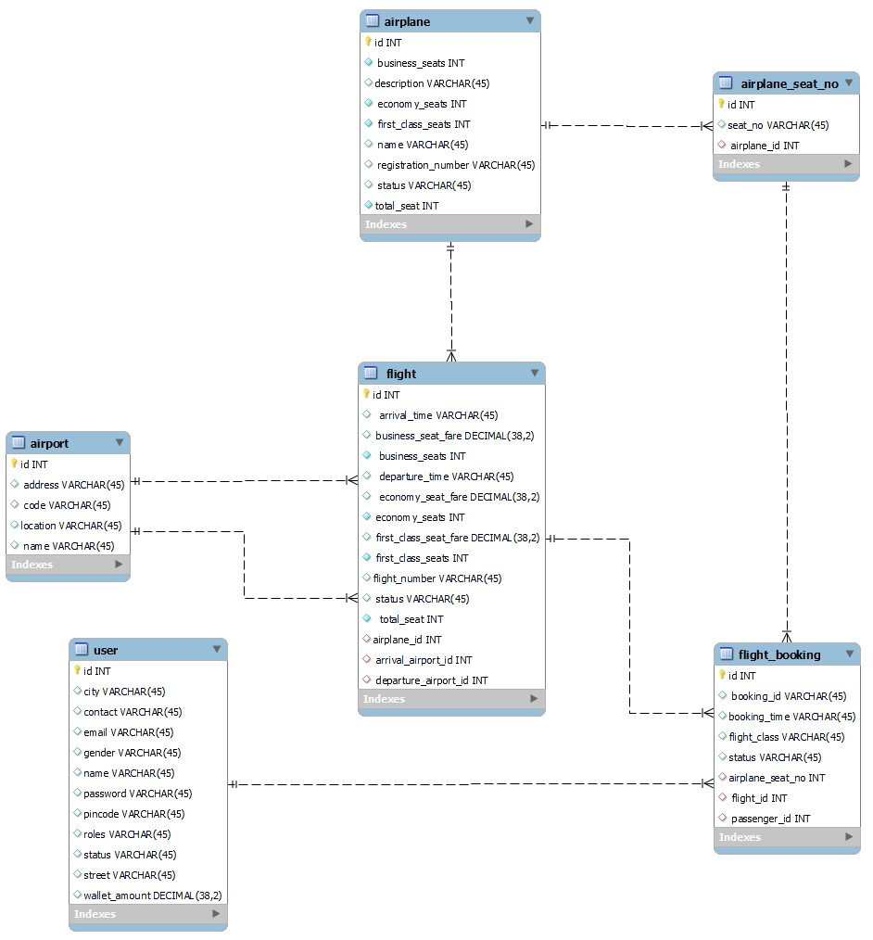

**Data Flow Diagram:**

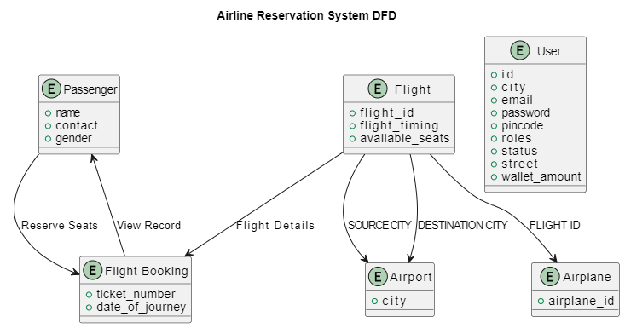

**Class Diagram**

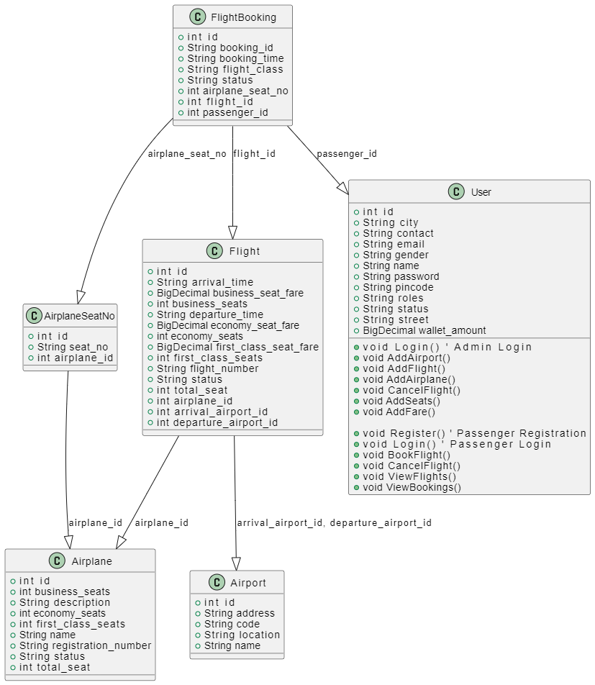

Appendix B

Homepage:

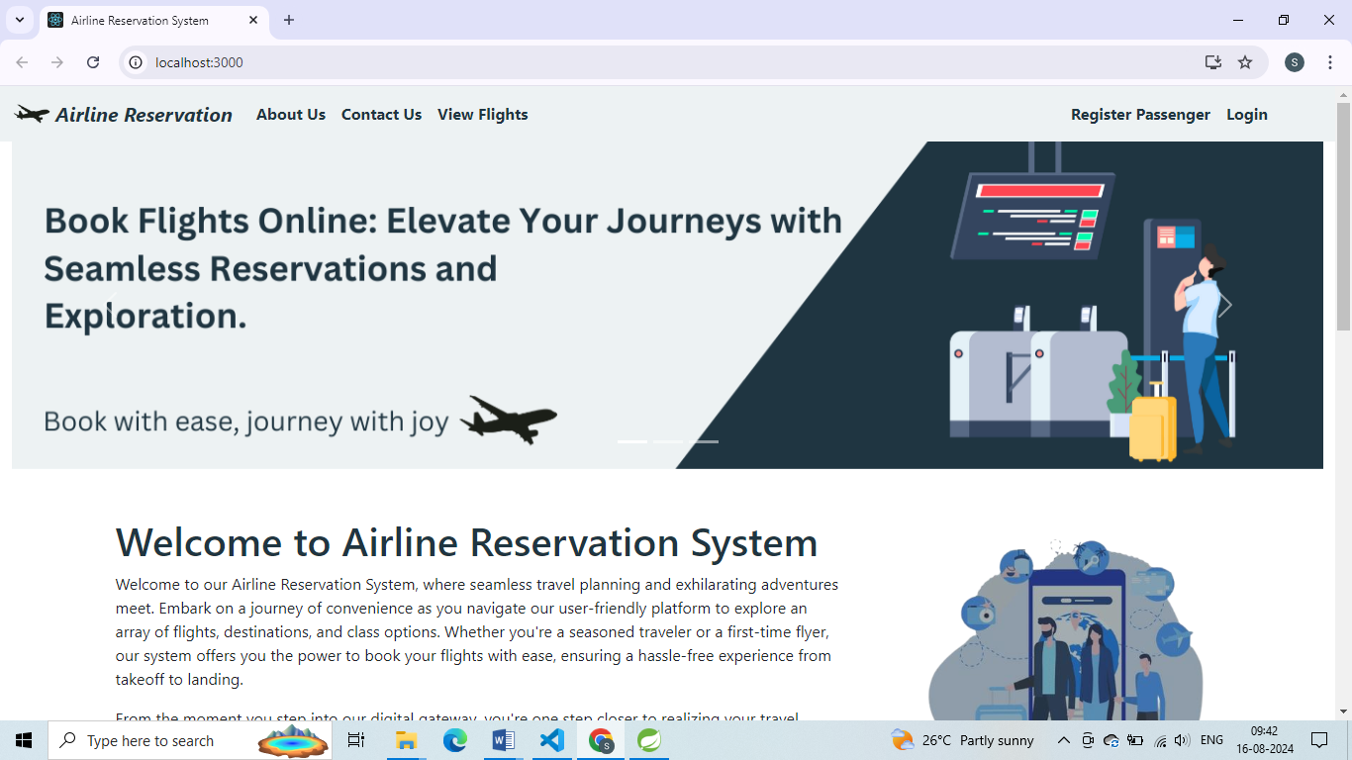

## ROLES OF USER

### ADMIN ROLE

#### 1) Admin will be able to Register into the System.

For the admin register, we have separate URLs i.e (http://localhost:3000/user/admin/register)

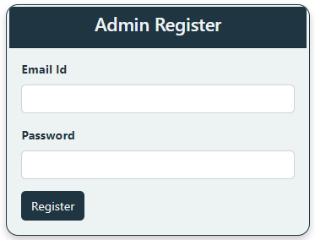

#### 2) Admin can log in to the System.

All Users (Admin & Customer) can log in to the system by selecting the role.

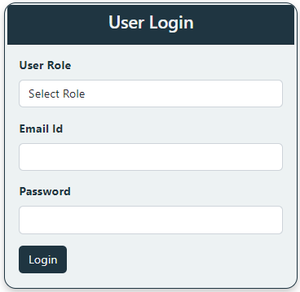

#### 3) Admin can add Airplanes in the Flight Reservation System.

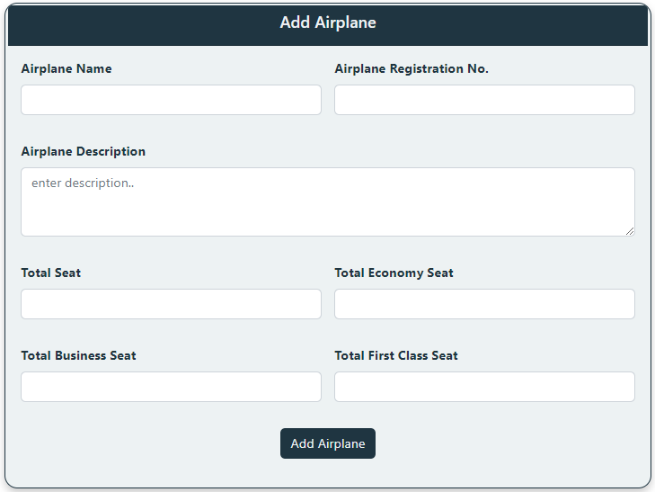

#### 4) Admin can view all Airplanes in the Flight Reservation System.

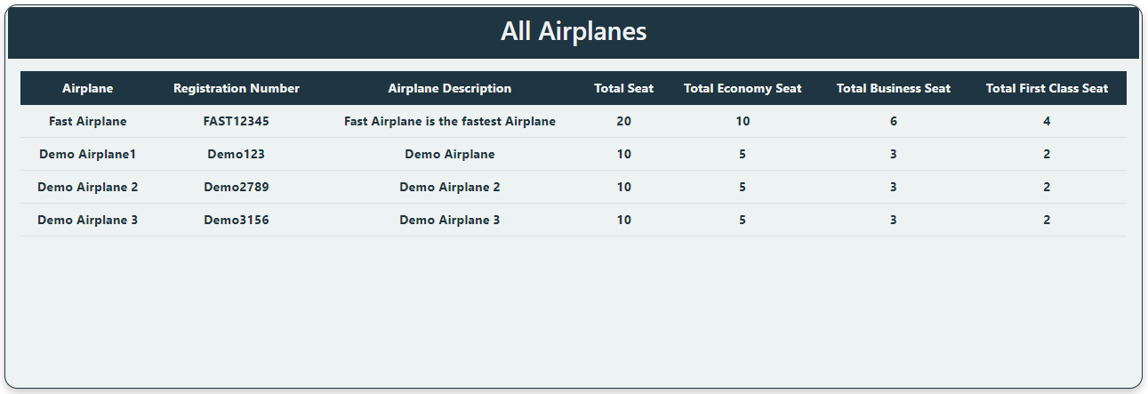

#### 5) Admin can add Airports in the Flight Reservation System.

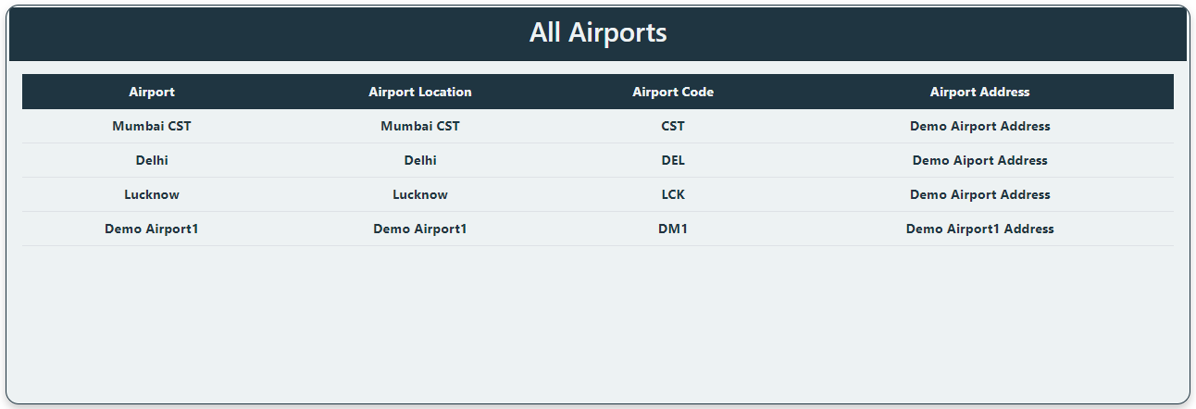

#### 6) Admin can view all Airports in the Flight Reservation System project.



#### 7) Admin can add the Flights to the Airline reservation system project

After adding the Airports and airplanes in the system, the Admin can add the Flights by selecting the departure & arrival airports and by selecting the departure & arrival times Also Admin has to specify the Seat Fare for all the Flight Seat classes i.e. for the Economy, Business and First Class as shown below.

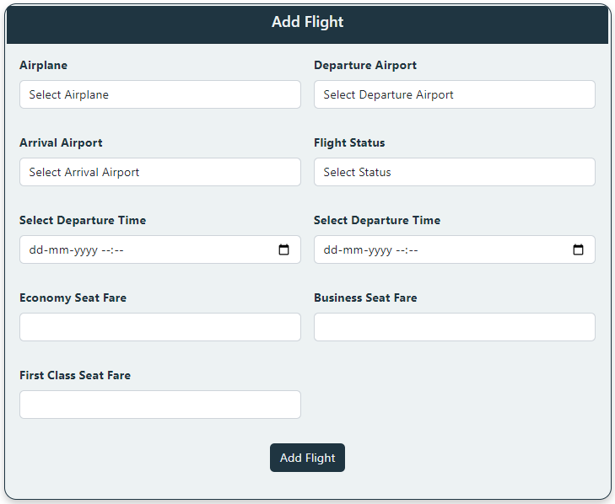

#### 8) Admin can view all the Scheduled Flights

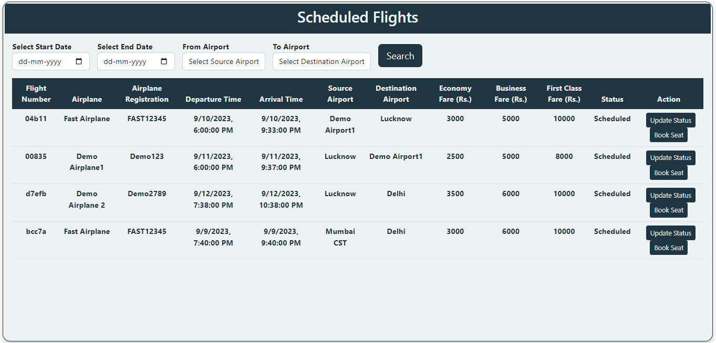

#### 9) The admin can update the Flight Status in the Flight Reservation System.

In the above screenshot, we can see Admin gets an option of Update Flight Status button, after clicking on the Button, we'll be able to see the below form and here he will be able to see the complete details of the selected Flight and from the below drop down he can select the status from (Scheduled, On Time, Delayed, Cancelled & Completed) and after selecting he can click on the update flight status button to update the Flight status.

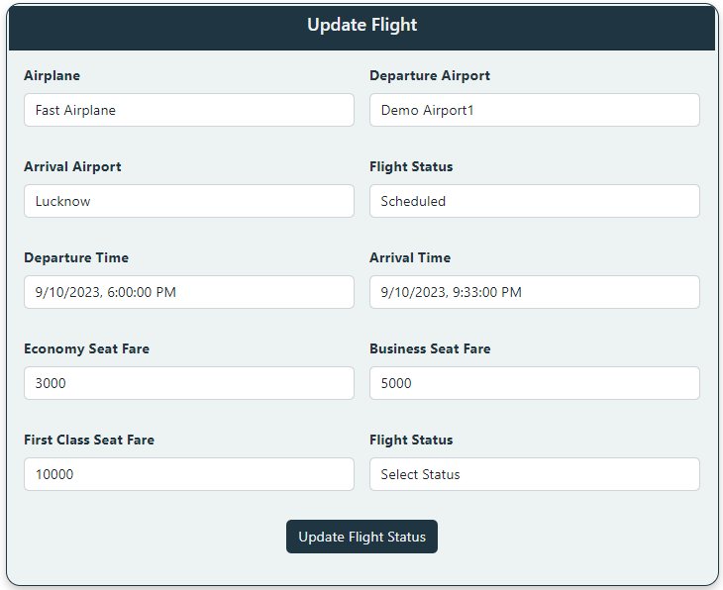

#### 10) The admin can view all the flight bookings.

Admin can view all the Flight Bookings from all the customers and he can also download the ticket at any time as shown below.

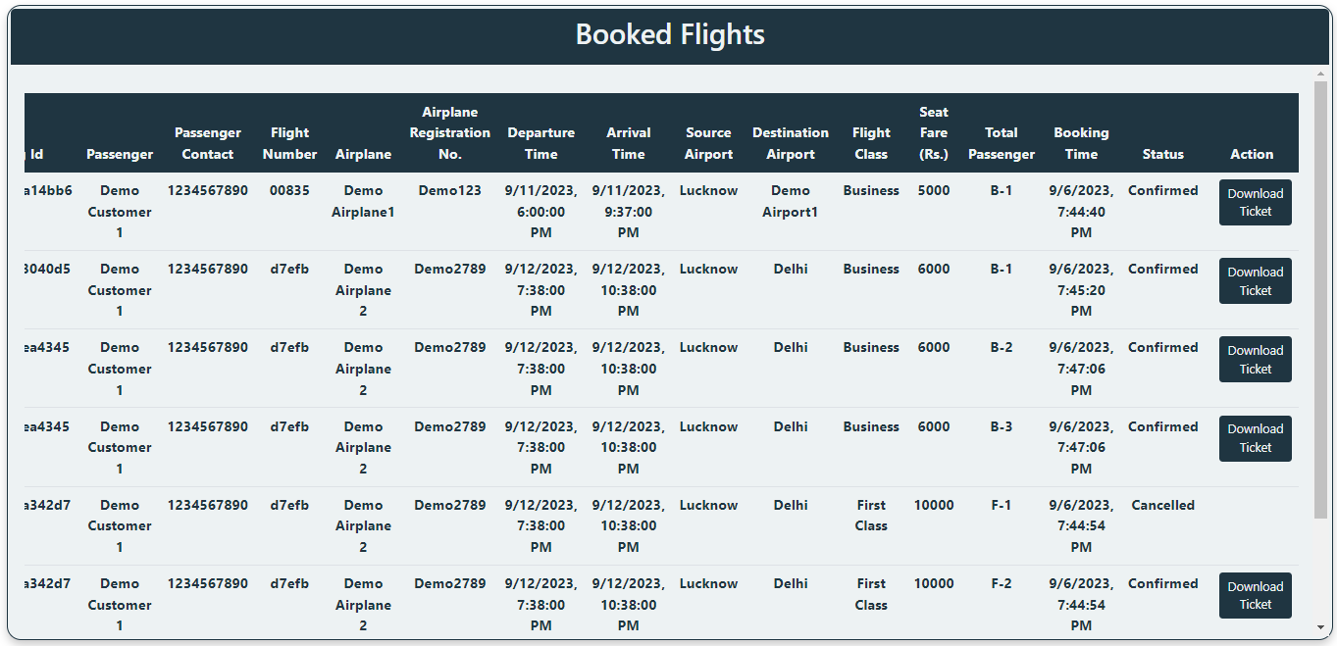

**Downloaded Flight Ticket in PDF Format**

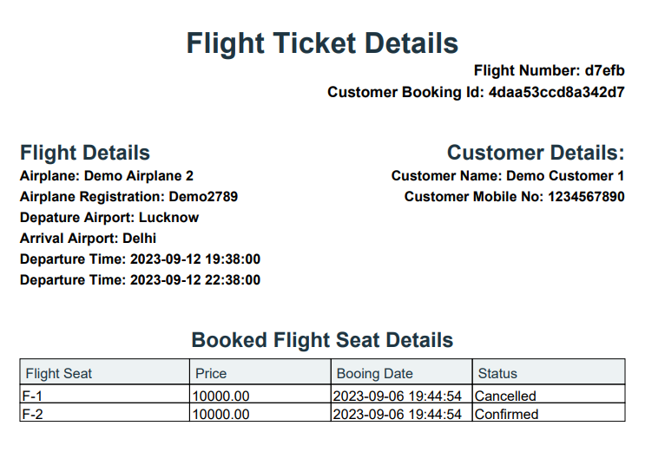

### CUSTOMER ROLE

#### 1) Customer can see all the Scheduled Flight

Customers can view all the Scheduled flights and they can all search the flights by selecting the departure & arrival airports with the departure time as shown below.

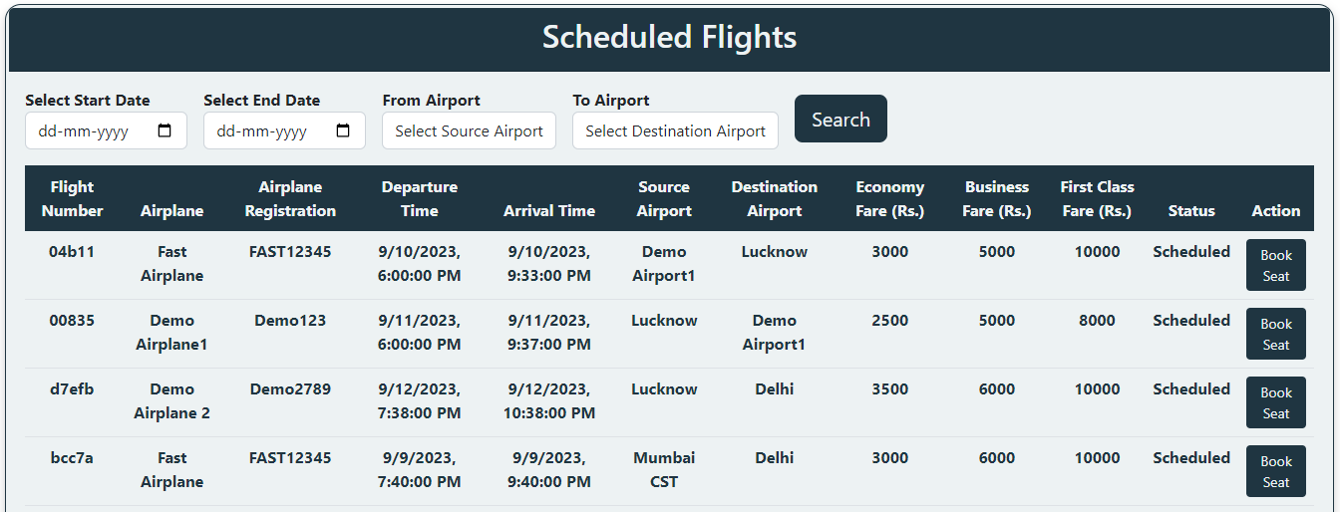

#### 2) Customers can book the Flights in the Airline Reservation System

In the above screenshot, we can see the customer has the option of Book Seat Button, after clicking on it, we will get redirected to the below page. Here customers will be able to see the complete information about the **Flight details**, **Airport Details**, **Airplane Details**,  etc., and along with this customers will be able to see the Flight Seat status whether seats are **Available** or **Confirmed**by other customers as shown below.

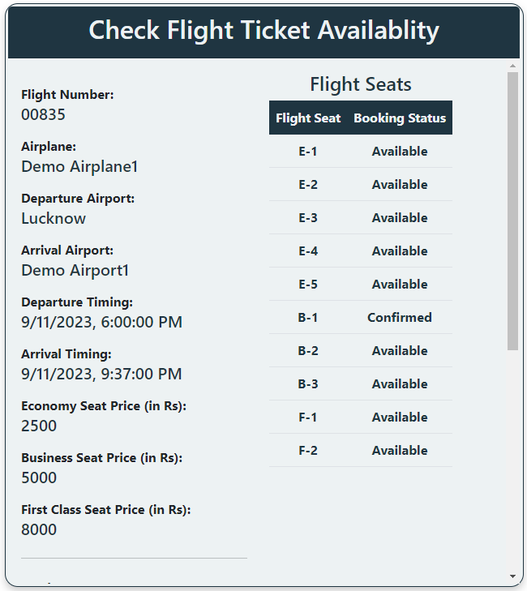

**On the above page, the below customer will get the option to book the ticket option, after clicking on it, they will get redirected to the below page and from the customer can add the number of passengers who will travel and select the Flight class type and he can click the Book Seat button for reservation.**

If a sufficient amount is present in the customer's wallet, then it will be confirmed immediately.

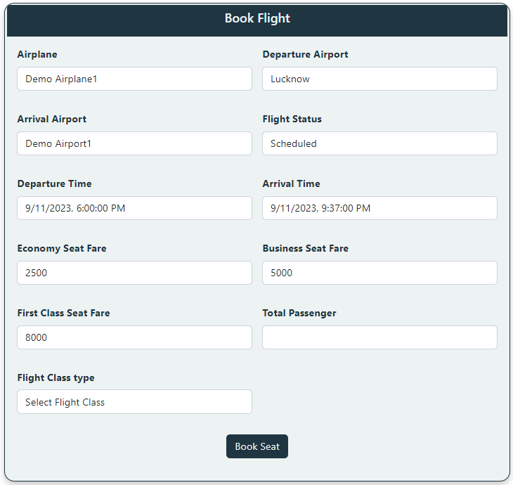

#### 3) Customers can view their Wallet.

Customers can add the money in Wallet and they see the available balance in the wallet as shown below.

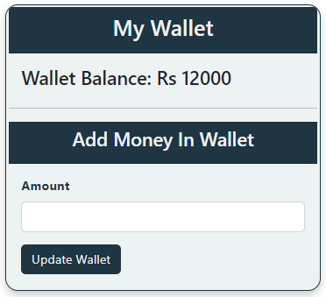

#### 4) Customers can view all their Flight Bookings.

Customers can view all Flight Bookings and also he can also **download** their **Flight tickets**from the Airline reservation system porta as shown below.

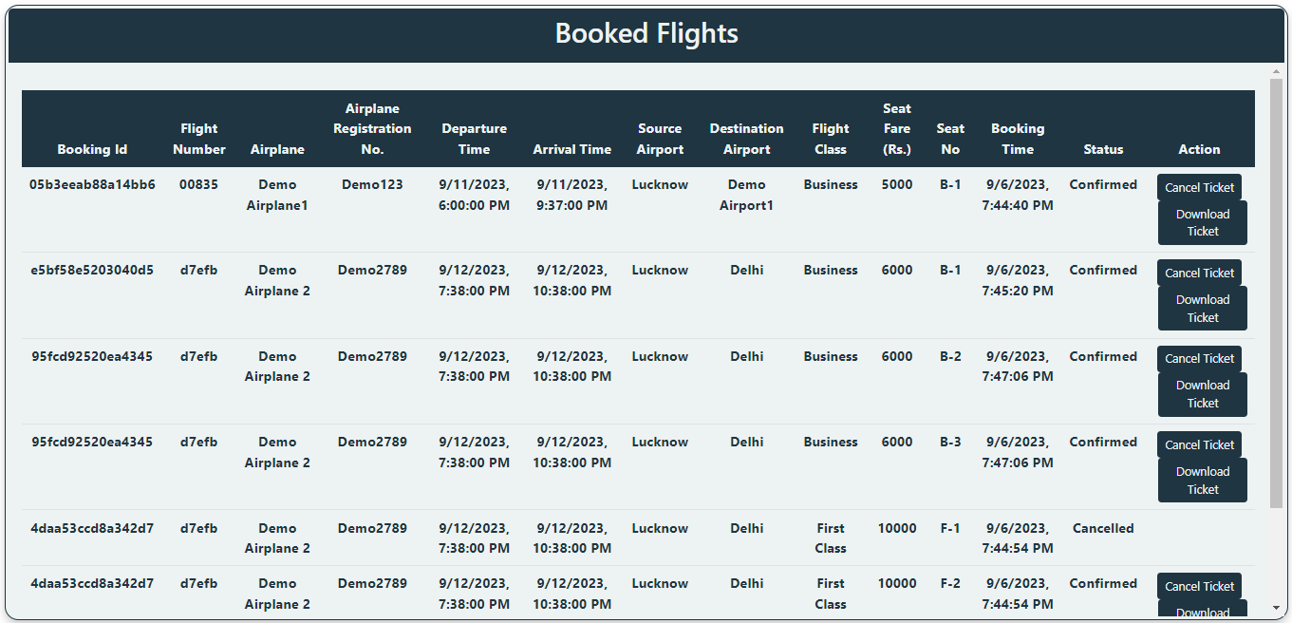

**Downloaded Flight Ticket in PDF Format**



**7.REFERENCES:**

<http://www.google.com>

[http://](http://www.xml101.com:8081/xml/)www.airIndia.com

http://www.webdevelopersjournal.com/

http://www.lufthansa.com

http://www.w3.org

http://www.wikipedia.org

http://www.delta.com

http://www.priceline.com